The landing page has two links to Sign up and Log in. P4 is an extension of P2 and P3. Sign up and Log in was leveraged from P2. The main functionality of P4 is after a user logs in.
The site is designed for entering estimates for the work packages that the application has been assigned.
The work packages are dispatched by an admin and the assignment of the work packages to the users, is out of the scope of this application. The users are being assigned with work packages via database scripts. The idea is to leverage this p4 and build admin functionality in future so that I can use this application in my work place. If you sign up as a new user, the user will not have any packages. New users will have to be associated to the users via database scripts.
The work packages once, are in a user's queue, the user will be able to update and add estimates.

Landing page:
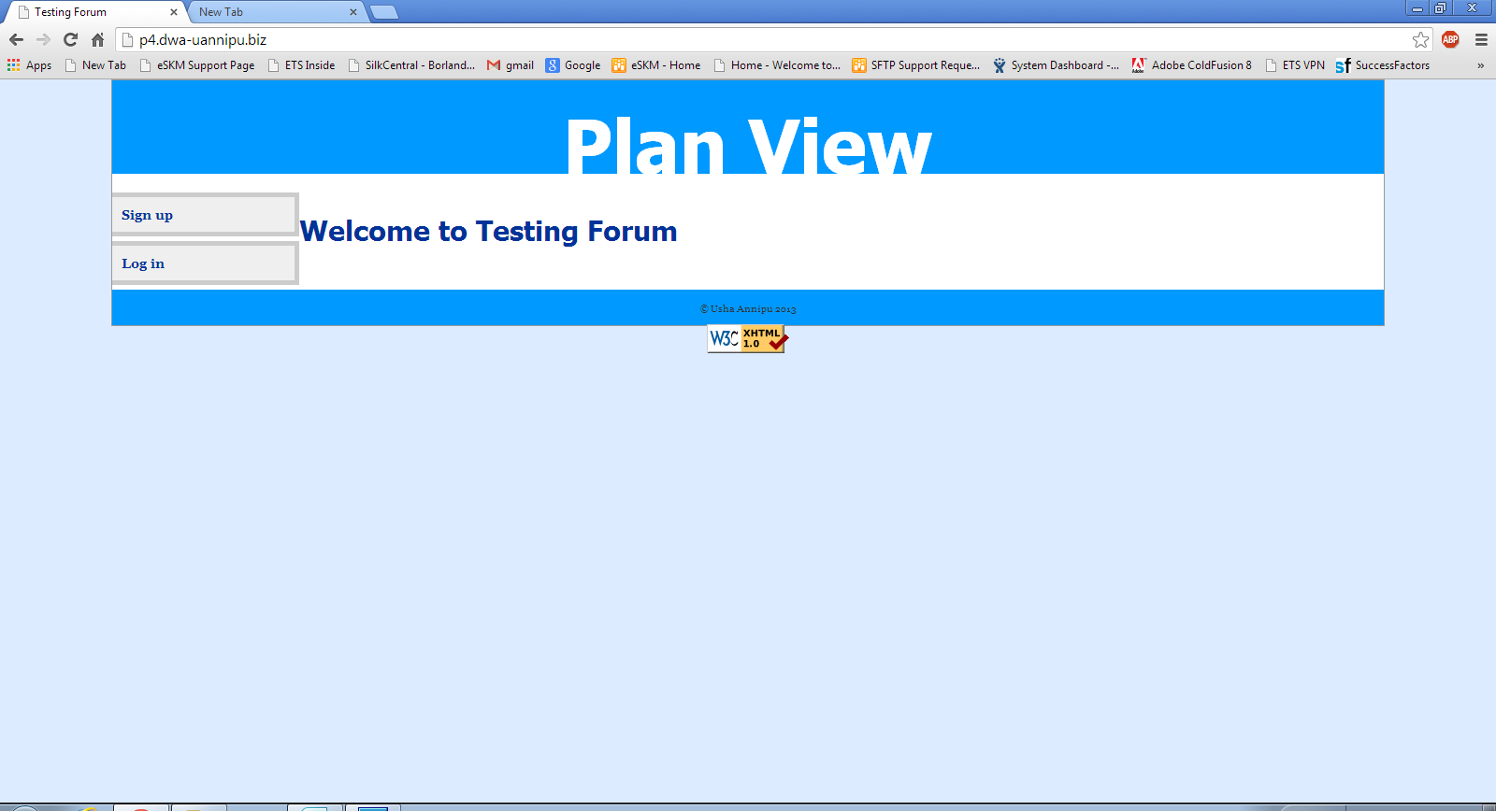

Log in – page : I created four users, user1, user2, user3 and usha. There are work packages associated to these users in the database.

login id : user1@gmail.com
pwd: user1

login id : user2@gmail.com
pwd: user2

login id : user3@gmail.com
pwd : user3

login id : uannipu@gmail.com
pwd: usha
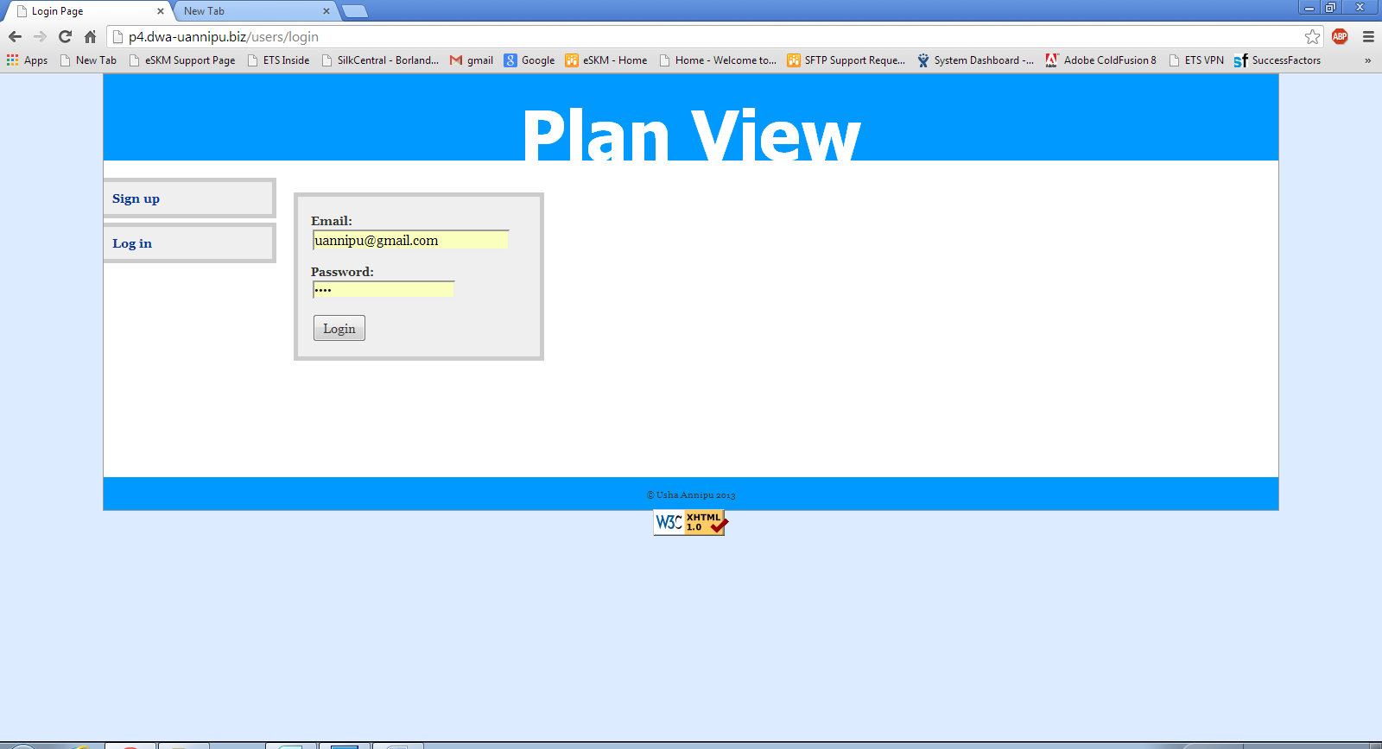

Home page :
The home page of the user looks like the below page, if the user already has work packages associated in the database. The index page, lists all work packages related to a user and package details. Once the work package is clicked, a user is directed to either add estimates screen or edit screen.
I used JQuery in the javascript and JQuery data grid plug in for the home/index page to be able to search and sort the list items by any column. The Total Hours and Total Amount are calculated fields.
In order to enter estimates, you have to click on the work package link Package id or package Desc on the home page.
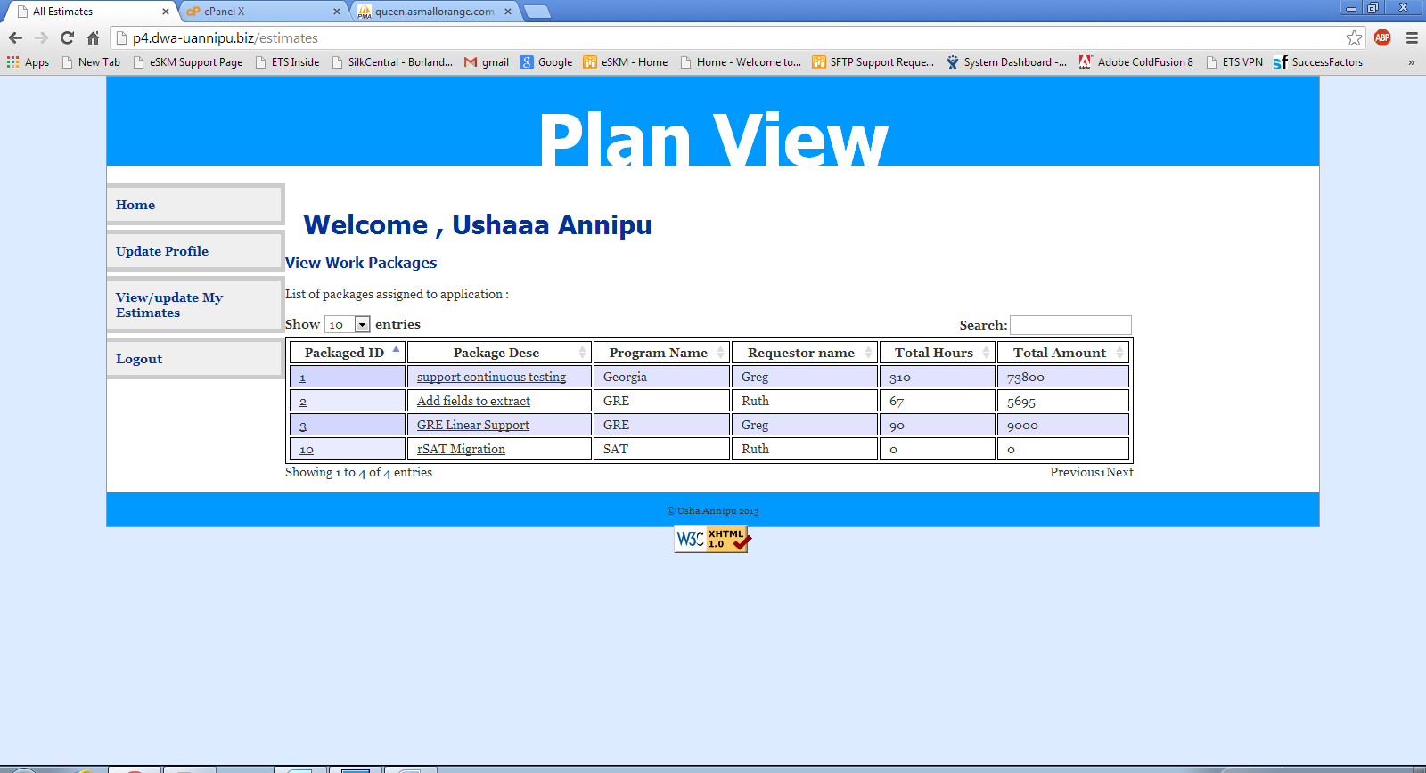

The Edit/update Estimate screen looks like below. The Work package Description and the each estimate line item is displayed. User can change any values , the preview will display updated amount and hours and other information dynamically on the preview. When the user is satisfied with the changes made, user clicks on ‘Save’ button that performs an ajax call to the back end to store the estimates.
There are three major tables, work_pckg, work_pckg_estimates, estimates. The user is associated to work packages. Multiple estimates can be associated to a particular work package.
More and Remove buttons are to add or delete the estimates within a work package and preview the numbers before saving the estimates for the entire work package. Used JQuery and Javascript to populate the dynamic table entries and calculate the totals.
Start Over button is to clear all the contents and start over the estimates.
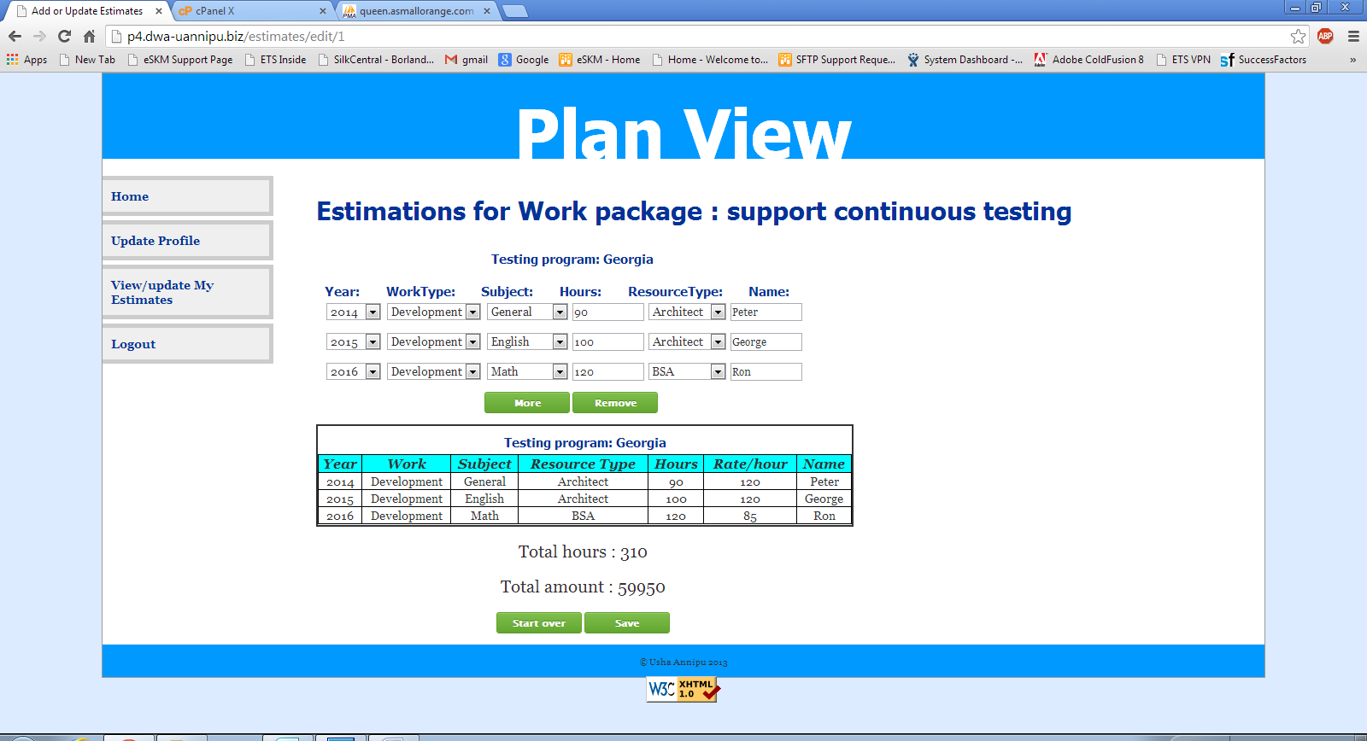

Confirm Ajax response: After the estimates are saved successfully in the database, the success message is displayed in ‘green’ that the ‘Estimates have been updated successfully’ as shown below.

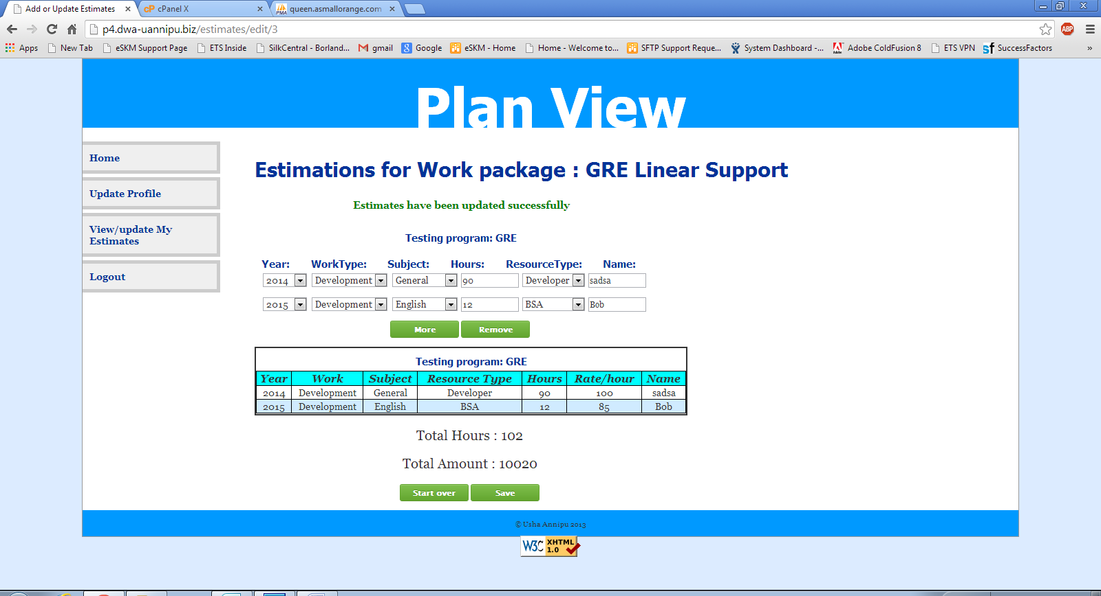

Add Estimate Page:
Once a user logs in and if there are new work packages associated to the user, the work packages may not have any estimates associated to them. A fresh work package normally does not have estimates, hence the total hours and total amount shows as 0 in the index page. In such cases ,the page looks like below. User can start entering the details and add more line items by using ‘More’ button. The estimates will get added to the work package once the user clicks the Save button.

